Project Management with Git
BCS358C
Semester 3

Course objectives:
To familiar with basic command of Git.
To create and manage branches
To understand how to collaborate and work with Remote Repositories.
To familiar with virion controlling commands

What is a Git?
Git is a version control system used for tracking changes in computer files. It is generally used for source code management in software development.
- Git is used to tracking changes in the source code
- The distributed version control tool is used for source code management
- It allows multiple developers to work together
- It supports non-linear development through its thousands of parallel branches
Features of Git
- Tracks history
- Free and open source
- Supports non-linear development
- Creates backups
- Scalable
- Supports collaboration
- Branching is easier
- Distributed development
The Git workflow is divided into three states:
- Working directory - Modify files in your working directory
- Staging area (Index) - Stage the files and add snapshots of them to your staging area
- Git directory (Repository) - Perform a commit that stores the snapshots permanently to your Git directory. Checkout any existing version, make changes, stage them and commit.
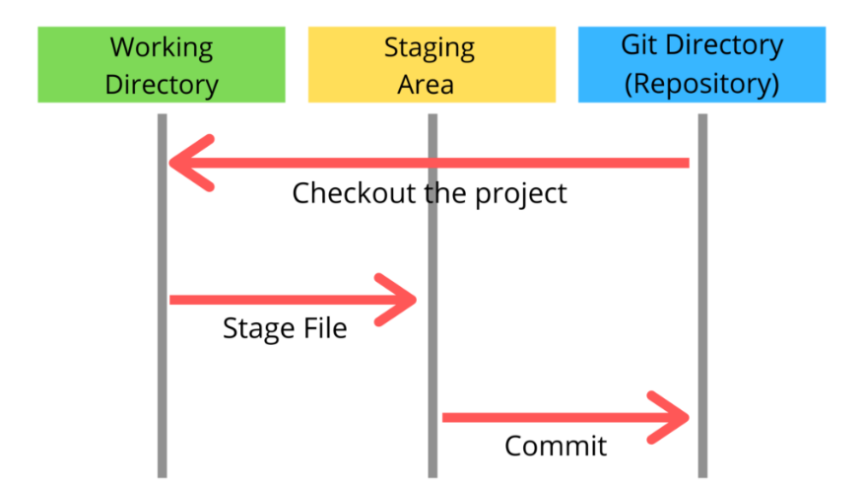
Figure-1: Git Workflow
Branch in Git
Branch in Git is used to keep your changes until they are ready. You can do your work on a branch while the main branch (master) remains stable. After you are done with your work, you can merge it with the main office.
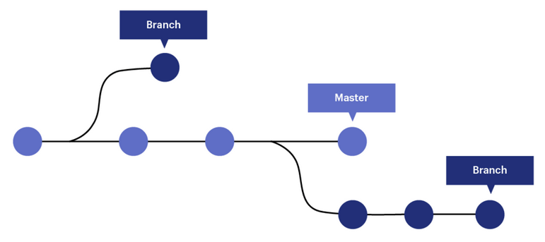
Git Installation on Windows
Download the latest version of Git and choose the 64/32 bit version. After the file is downloaded, install it in the system.
Check the Git version:
Open the terminal (press Windows+R button on keyboard, dialog box opens, write cmd and press enter)
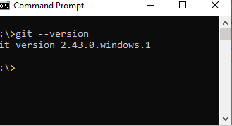
Experiment-1
Setting up and basic commands
Initialize a new Git repository in a directory. Create a new file and add it to the staging area and commit the changes with an appropriate commit message.
Solution
Step-1: Create a local directory “test” using the command: mkdir test
and change the directory by using the command : cd test
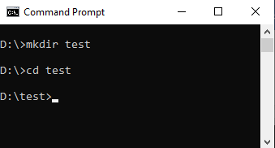
Step-2: The next step is to initialize the directory: git init
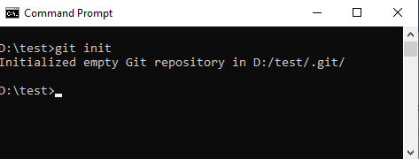
Step-3: Open windows explorer, go to the folder where "test" is created and create a text document named "demo.txt". Open "demo.txt" file and edit any content. Save and close the file.
Step-4: Type the following command in terminal: git status
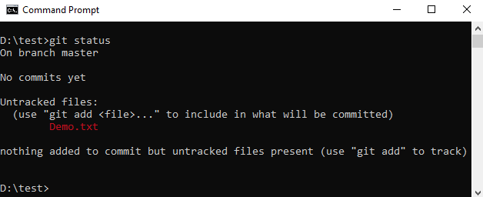
Step-5: Add the "demo.txt" to the current directory using the following command:
git add demo.txt
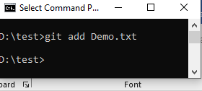
Commit: It is used to record the changes in the repository. It is the next command after the git add. Every commit contains the index data and the commit message.
Step-6: Before committing, one has to update the author details, which includes name and email id using the following commands
git config --global user.email "you@example.com"
git config --global user.name "Your Name"
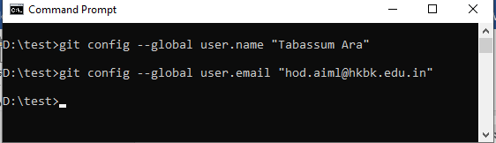
Step-7: Next, make a commit using the following command:
git commit -m "committing a text file"

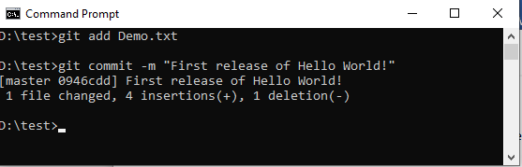
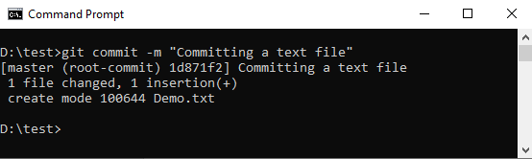

Optional Steps:
git log: to check the log report
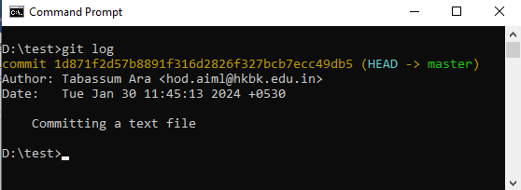
Update the file “demo.txt” save the file and commit it.
Now we can check the difference using the diff command.
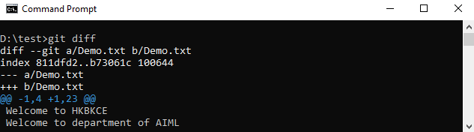
Whenever we commit, a new version will be created and saved with one id. We can use these ids to find the difference between two versions.
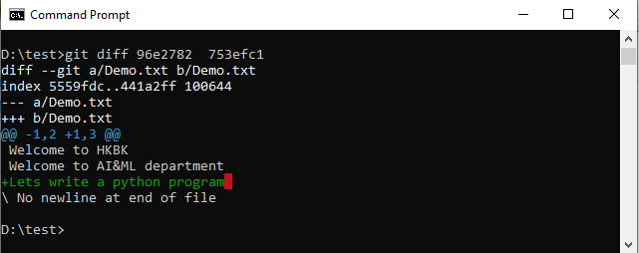
The git blame command displays the details of the author who last modified or added each line of code in a given file along with the commit id of modification.
If the file is not committed the below output will be displayed.
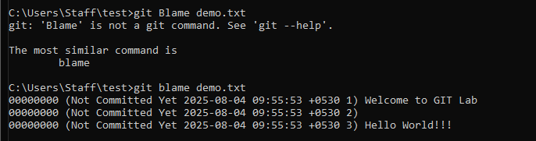
If the file is committed then it displayed the Author name , who modified the data
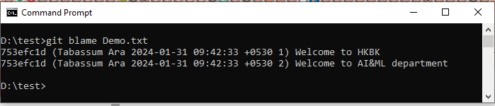

Experiment-2
Creating and Managing branches
Create a new branch named “feature-branch”. Switch to the “master” branch. Merge the “feature-branch” into “master”
Branch
In Git, a branch is a new/separate version of the main repository. Branches allow you to work on different parts of a project without impacting the main branch.
When the work is complete, a branch can be merged with the main project.
You can even switch between branches and work on different projects without them interfering with each other.
To create a new branch, use the command: git branch “name of the branch”
The command “git branch” displays all the branches created under the master branch. And * indicates we are currently on this branch.
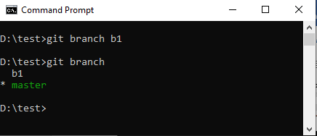
Checkout;
checkout is the command used to check out a branch. Moving us from the current branch, to the one specified at the end of the command:
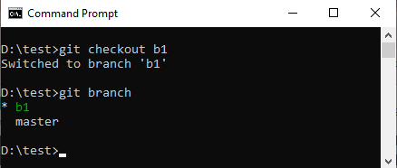
Check the status
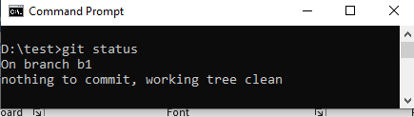
Now create a new file “sample-1.txt” and edit some content to this file and save it. Once saved , add it to git and commit the changes made.
Now if you list the files using dir command, you will see 2 files, Demo.txt and sample-1.txt.
Next you can change the branch to master branch using the command: git checkout master
Now if you list the files using dir command, you will see only 1 file, Demo.txt.
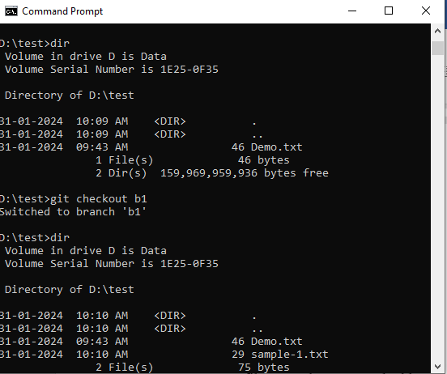

Merging branches
First, we need to change to the master branch using the command: git checkout master
Now use the command : git merge “name of the branch”
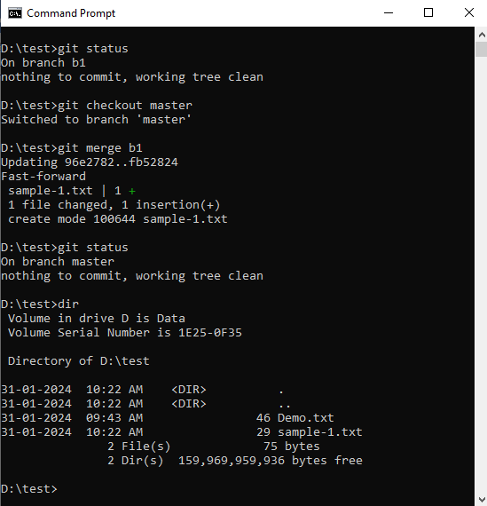
Now the branch is not required, hence we can delete the branch using the command: git branch -d b1
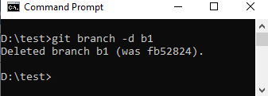

Exercise
  - Check the status
  - Create a new branch.
  - Switch it to the new branch
  - Add new file in this branch and commit
  - Check the log
  - Switch back to master branch
  - Check the log again
  - Merge your branch to master
  - Commit the changes
  - Check the log
Experiment-3
Creating and Managing Branches
Write the commands to stash your changes, switch branches, and then apply the stashed
changes.

Stashing
Sometimes you want to switch the branches, but you are working on an incomplete part of your current project. You don't want to make a commit of half-done work. Git stashing allows you to do so. The git stash command enables you to switch branches without committing the current branch.

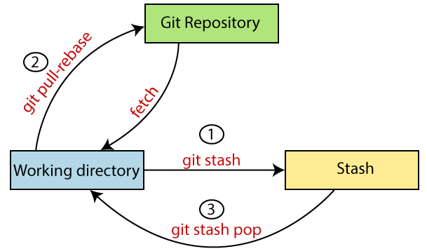

- Stash your changes:
  - Basic stash: git stash
  - Stash with a message: git stash save "Meaningful message"
- Switch branches:
  - Switch to a specific branch: git checkout <branch_name>
- Apply the stashed changes:
  - Apply the latest stash: git stash pop (apply and drop)
  - Apply and keep the latest stash: git stash apply

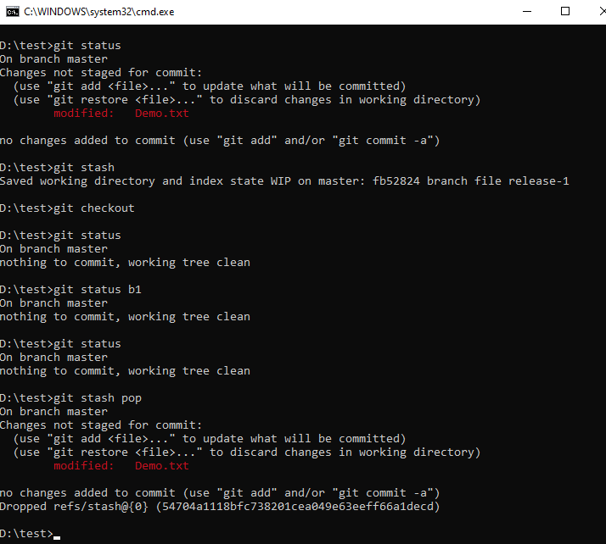

Exercise
Imagine that you are working on two branches. You are currently making changes to the first branch, but then your team informs you that something also needs to be changed on the second branch. How do you do? List all the commands.

Experiment-4
Collaboration and Remote Repositories
Clone a remote Git repository to your local machine.
1. Creating a new repository on GitHub first:
- Go to GitHub and sign in to your account.
- Click on the "New repository" button.
- Fill in the repository name, optionally add a description, and choose whether to make it public or private.
- Click "Create repository".
- Open a terminal or command prompt on your local machine.
- Navigate to the directory containing your local Git repository.
git remote add origin <url>
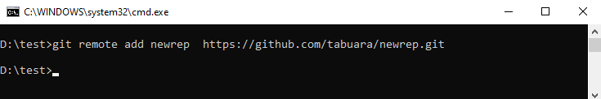
git push -u origin main
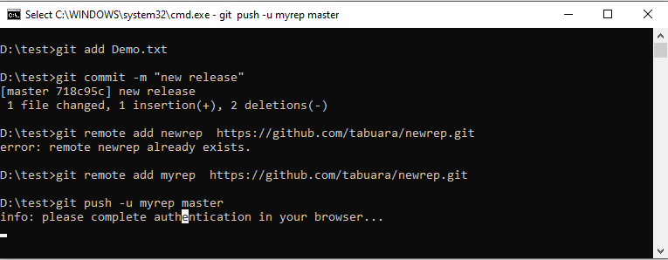
Now cloning a remote Git repository to your local machine
- Get the repository URL: Locate the repository you want to clone on the platform it's hosted on (e.g., GitHub, GitLab, Bitbucket). Copy the URL provided for cloning using HTTPS.
- Open a terminal or command prompt: Navigate to the directory where you want to store the cloned repository.
- Run the git clone command: Type the following command, replacing <url> with the copied URL:
git clone <url>
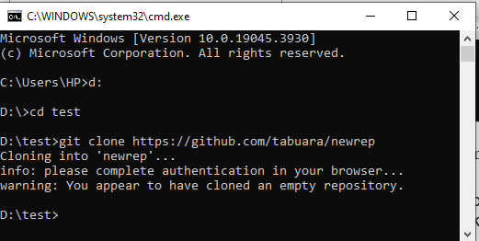

Experiment-5
Collaboration and Remote Repositories
Fetch the latest changes from a remote repository and rebase your local branch onto the
updated remote branch.

What is git rebase?
Rebase is used to integrate changes from one branch onto another. Rebasing is the process of combining or moving a sequence of commits on top of a new base commit. Git rebase is the linear process of merging.

Fetch the Latest Changes from the Remote Repository
To fetch the latest changes, use the following command
git fetch
This command retrieves the latest changes from the remote repository without modifying your local branches.

Switch to the Branch You Want to Rebase
git checkout <branch name>

Rebase the Local Branch onto the Remote Master Branch
Git rebase origin/master
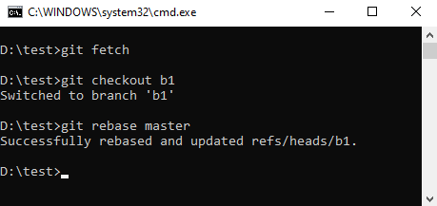

Experiment-6
Collaboration and Remote Repositories
Write the command to merge "feature-branch" into "master" while providing a custom
commit message for the merge.
Step-1: Check the status. Now it is in branch b1
Step-2: (optional) create branch b2
Step-3: (optional) create a file testfile.txt
Step-4: (optional) add file for tracking
Step-5: Checkout to master
Step-6: Merge the branch b2 to master using the command
git merge b2 -m "merging b2 to master"

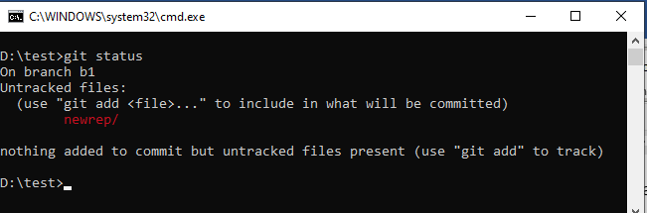

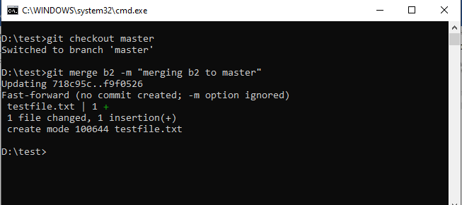

Experiment-7:
Git Tags and Releases
Write the command to create a lightweight Git tag named "v1.0" for a commit in your local
repository.
Git tags represent specific reference points in a software development project's history.
Git tags are used to denote specific points in the project's history. Tags usually mark a feature release but can also indicate commits. Git tags are similar to Git branches, except no changes can be made to a tag after creation.
You can tag any commit but typically users tag release versions. Once a tag is created, it includes all the changes made to the project and it acts as a git branch that doesn't change. Git tags are excellent for comparing commits.
here are two types of Git tags:
- Annotated tags. They contain metadata about the user creating the tag, such name, email address, and date.
- Lightweight tags. Does not contain any additional metadata. It just points to a commit.

Create a lightweight tag using the following syntax:
git tag [tag name]

Create Git Tag For a Commit
Create a Git tag for a particular commit from Git history by specifying the commit SHA. Obtain the commit SHA by running:
git log --oneline
After obtaining the commit SHA, create a tag using the following syntax:
git tag [tag name] [commit SHA]

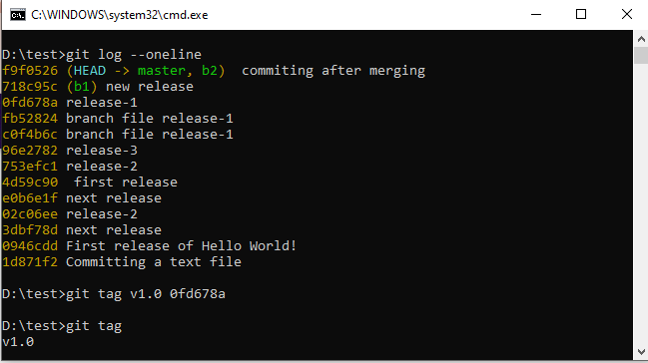

Experiment-8
Advanced Git Operations
Write the command to cherry-pick a range of commits from "source-branch" to the current branch.

Pick arbitrary commits from specific branch and append them as the HEAD of destination branch.

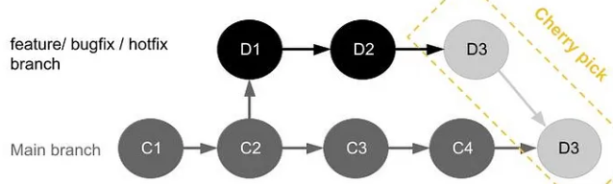

.Step-1: To get the references of commits of any branch, from any branch.
git log --oneline <source-branch>
Step-2: Checkout to the target branch.
git checkout <target-branch>
- Step-3: Cherry-Pick Multiple Commits By range commits:

git cherry-pick <oldest-commit-hash>^..<newest-commit-hash>

The ^ after <start-commit-hash> is used to exclude the starting commit from the range. This means that the commit with the hash <start-commit-hash> will not be cherry-picked, but the subsequent commits up to and including <end-commit-hash> will be cherry-picked.
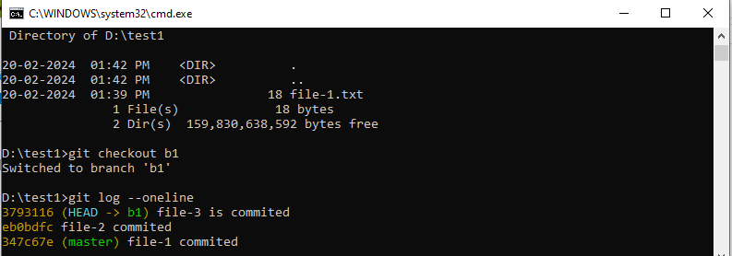

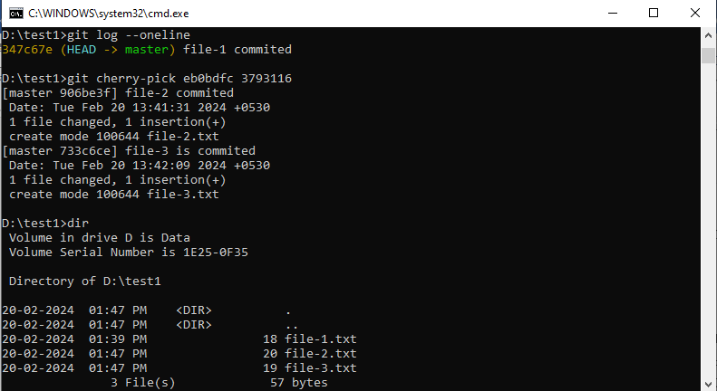

Experiment-9
Analysing and Changing Git History
Given a commit ID, how would you use Git to view the details of that specific commit, including the author, date, and commit message?

Git show -l <commit ID>

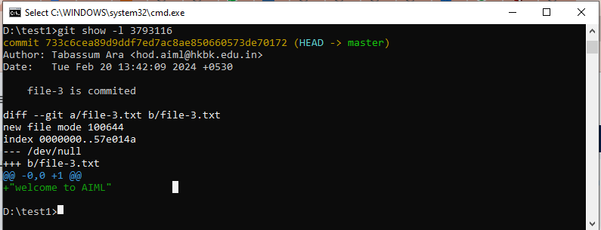

Experiment-10
Analysing and Changing Git History
Write the command to list all commits made by the author "JohnDoe" between "2023-01-01"
and "2023-12-31."

git log --author="JohnDoe" --since="2023-01-01" --until="2024-01-01"
- git log: This is the core command to view Git commit history.
- --author="JohnDoe": This filters the commits to only those authored by "JohnDoe".
- --since="2023-01-01": This sets the lower bound of the date range to "2023-01-01".
- --until="2024-01-01": This sets the upper bound of the date range to "2024-01-01".

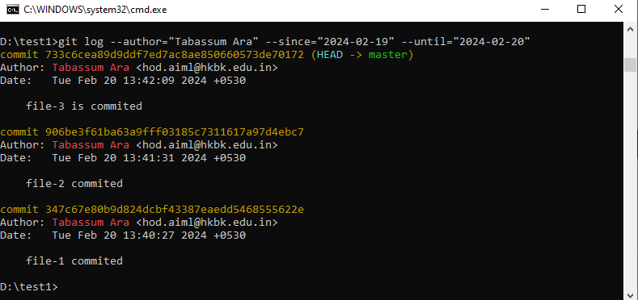

Experiment-11
Analysing and Changing Git History
Write the command to display the last five commits in the repository's history.

git log -5
This command will display the last five commits by default.

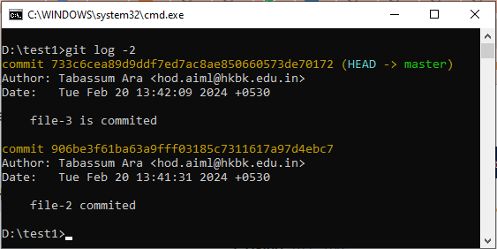

Experiment-12

Analysing and Changing Git History
Write the command to undo the changes introduced by the commit with the ID "abc123".

git reset --hard abc123^

This completely removes the commit and its changes from your working directory and staging area
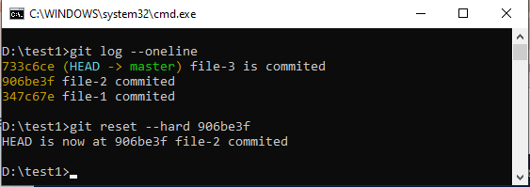

Course outcomes (Course Skill Set):
At the end of the course the student will be able to:
Use the basics commands related to git repository
Create and manage the branches
Apply commands related to Collaboration and Remote Repositories
Use the commands related to Git Tags, Releases and advanced git operations
Analyse and change the git history

